Practice Exercise

This document provides a list of exercises to be practiced by learners. Please raise a feedback in Talent Next, should you have any queries.

|  |  |
| --- | --- |
| Skill | HTML5 & CSS3 |
| Document Type | Lab Practice Exercises |
| Author | L & D |
| Current Version | 1.0 |
| Current Version Date | 16-Jun-2021 |
| Status | Active |

Document Control

|  |  |  |  |
| --- | --- | --- | --- |
| Version | Change Date | Change Description | Changed By |
| 1.0 | 16-Jun-2021 | Added a problem statements on Navigation Bar, Menu Bar, Card and List Layout, Containers Tag, Form Field and Tables Tags. | Pradeep Chinchole |

Contents

Practice Exercise 1

Document Control 2

Problem Statement 1: Creating Navigation bar using HTML5 and CSS3 4

Problem Statement 2: Creating Customer Menu bar using Anchor Tags, Images, Search Field 5

Problem Statement 3: Designing the Card Layout for Customer Details 6

Problem Statement 4: Designing the List Layout for Customer Details 7

Problem Statement 5: Designing Customer Details Page using Container Tag 8

Problem Statement 6: Designing Form to Add Customer Details using HTML5 Forms Fields 9

Problem Statement 7: Designing Order Details Page using HTML5 Table & List 12

Problem Statement 8: Designing About and Login Page 13

Note: Every Problem Statement start in a new page

Problem Statement 1: Creating Navigation bar using HTML5 and CSS3

Introduction

**Important Instructions:**

* Refer the Lab Access Guide document for accessing the HTML5 & CSS3 live online playground.
* Refer <https://playcode.io/new/> link to access online playground.

A client wants to develop online shopping application for customers with the goal that it is very easy to shop your loved things from an online shopping site available on the web and carry out the online shopping from their home. The client approached Mphasis to develop the front-end pages for online shopping application using HTML5 and CSS.

The Mphasis UI developer started developing the website beginning with the Navigation Bar.

Create an **Navbar.html** as per below image which has links to other below pages using HTML5 & CSS3.

* CustomerDetails.html –Display the list of customers.
* OrderDetails.html – Display the orders of all customers.
* About.html – Render details of the E-Shopper.
* Login.html – Display the login page that accepts credentials.
* The Above pages must be loaded when specific link is clicked.
* Use CSS3 to apply background color for navbar & font style, margin to the links on the navbar.



Problem Statement 2: Creating Customer Menu bar using Anchor Tags, Images, Search Field

Create a **CustomerDetails.html** with anchor tags and images as per below image.

* Card View: Display the Customer details in card format.
* List View: Display the Customer details in list format.
* New Customer: Display the form to add the customer.
* Search Bar : Text Field to display the customer by text entered in the filter.
* Use CSS3 to apply font style, margin to the links on the Customer menu.
* Use CSS3 to apply width & height for Icons on Customer menu.

**CustomerDetails.html:**

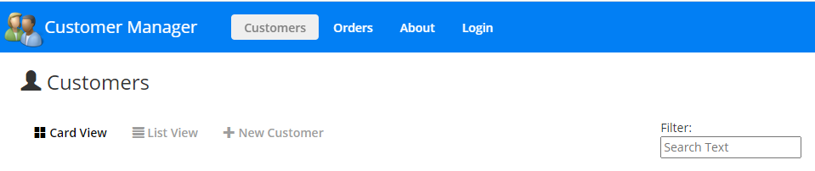

Problem Statement 3: Designing the Card Layout for Customer Details

Create a **CustomerDetailsCardLayout.html** as per below image to display below customer details in card format.

* Customer Name (with edit Icon to edit the customer details using form)
* Customer City
* Customer State
* Customer Gender (Male/Female icons should be displayed based on gender value)
* View Orders (Link to be created for showing the orders of the specific customer)
* Use CSS3 to set the width & height of Edit, Male/Female Icon.
* Use CSS3 to set the color & background color for element holding Customer Name & Edit icon.
* Use CSS3 to set the border & margin for container tag holding Customer Details.

**CustomerDetailsCardLayout.html:**

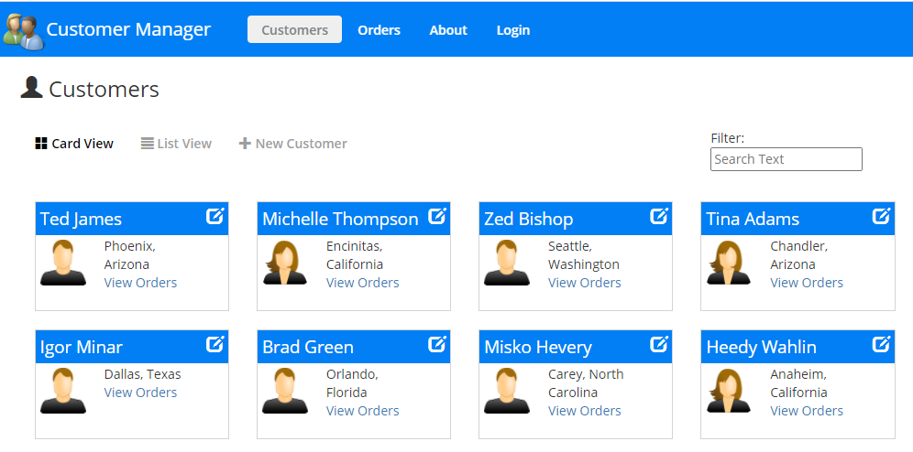

Problem Statement 4: Designing the List Layout for Customer Details

Create a **CustomerDetailsListLayout.html** as per below image to display below customer details in list format.

* First Name (Link to be created for showing the details of customer)
* Last Name
* Address
* City
* State
* Order Total in USD
* Customer Gender (Male/Female icons should be displayed based on gender value)
* View Orders (Link to be created for showing the orders of the specific customer)
* Use CSS3 to set width, height & margin to Male/Female icon & Customer icon.
* Use CSS3 to apply different properties (cell spacing, cellpadding) to table.

**CustomerDetailsListLayout.html:**

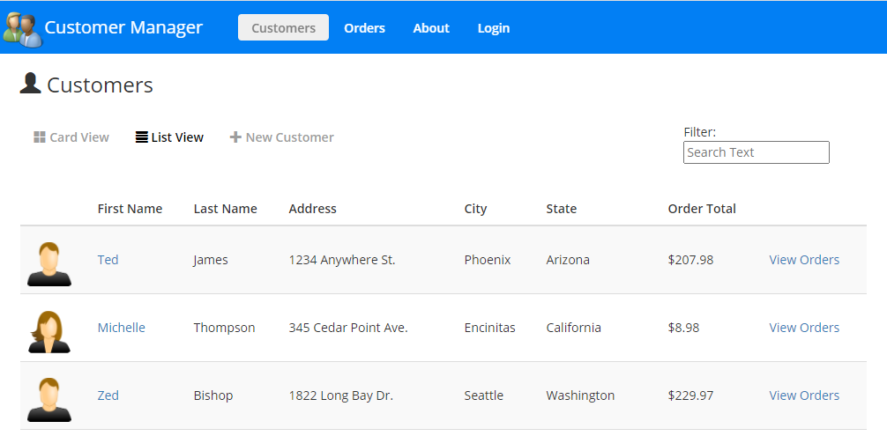

Problem Statement 5: Designing Customer Details Page using Container Tag

Create a **GetCustomerDetails.html** as per below image to show the below customer information using container tags.

* Male/Female Icon should be displayed based on gender value.
* Name
* Address
* State
* City
* View all Customers (Link to show all the customers in card format)
* Use CSS3 to set width, height, and margin for Male/Female icon & font style for Customer Name.

**GetCustomerDetails.html:**

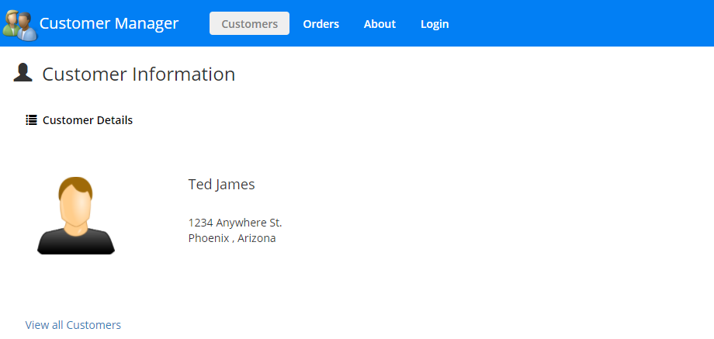

Problem Statement 6: Designing Form to Add Customer Details using HTML5 Forms Fields

Create **NewCustomerDetails.html** to accept below customer details & Implement Client-Side validations using HTML5 form features.

* **First Name:**

Text Field: It is required

* **Last Name:**

Text Field: It is required

* **Email:**

Text Field : It is required & should be a valid email address.

* **Mobile:**

Text Field: It is required & should be valid mobile(10 digits only)

* **Subscription:**

Checkbox: By default, checked.

* **Gender:**

Data List: It is required: Value must be (Male | Female |Other)

* **Date of birth:**

Date Picker: It is required & should accept in format (mm/dd/YYYY)

* **Favorite color:**

Color Picker: It is required

* **Address:**

Text Area: It is required

* **City:**

Drop down: It is required.

* **State:**

Drop down: It is required.

* **Country**:

Drop down: It is required.

* **Cancel**:

Reset button: To reset the form data.

* **Insert**:

Submit button: To add the customer.

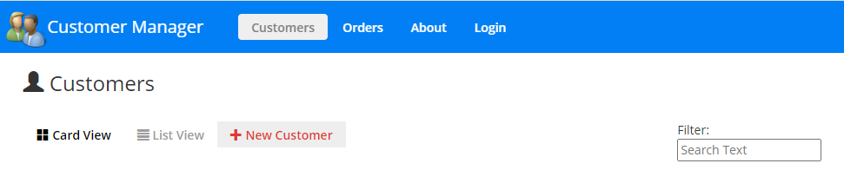

Once you click on **New Customer link** it will display the form to add the customer details as below:

* Use CSS3 to apply color(green) for Text Fields when field value is entered.
* Use CSS3 to apply color(red) for Text Fields when field value is empty.

**NewCustomerDetails.html:**

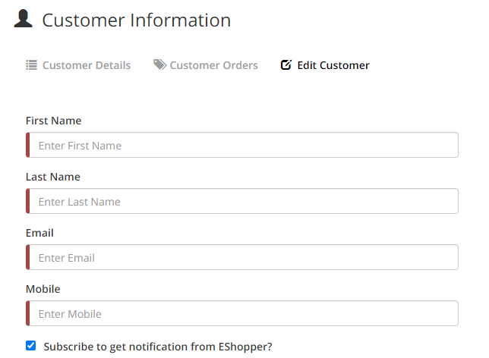

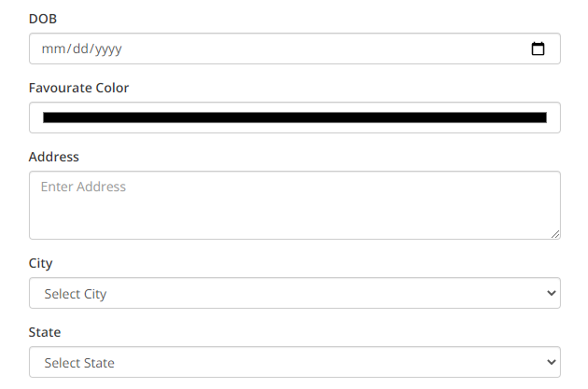

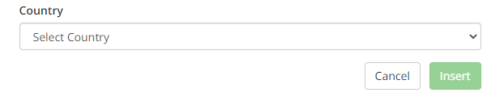

Problem Statement 7: Designing Order Details Page using HTML5 Table & List

Create **OrderDetails.html** to show the orders details of all customers using Table & Ordered Lists tags as per below image.

* Customer Name
* Product Name
* Product Price
* Order Price
* Use CSS3 to set margin of Orders Icon & font style, font size for Customer Name.

**OrderDetails.html:**

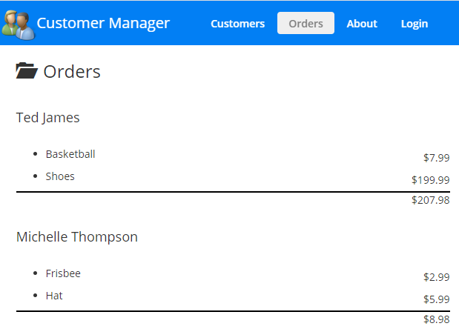

Problem Statement 8: Designing About and Login Page

**8.1:** Create **About.html** to show the below details as per below image.

* Your Name (Link to tweeter)
* Git hub (Link to GitHub repository)
* Role
* Email
* Address
* Use CSS3 to apply the italic style for Address & Margin for About Icon.

**About.html:**

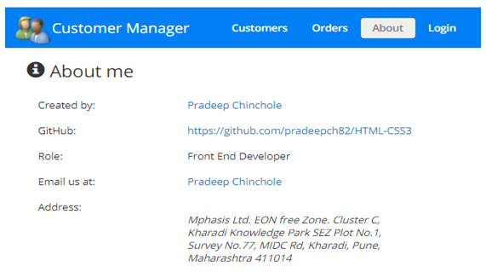

**8.2:** Create a **Login.html** to accept the email and password.

* Implement Client-Side validations using HTML5 features.

1. Textboxes cannot be empty.
2. Password min length – 6 Characters.
3. Password min length – 10 Characters.
4. Password should be a combination of letters, number and 1 special character.
5. Submit button should be disabled till the validation is passed.
6. Use CSS3 to set color for Login Button & color(brown) for required Email & Password Field.
7. Use CSS3 to set the margin for Login Icon.

**Login.html**

